Exercise 1

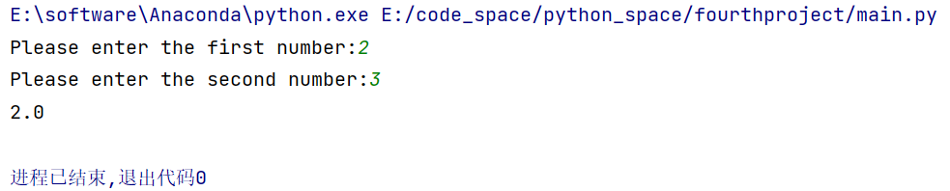

Exercise 2

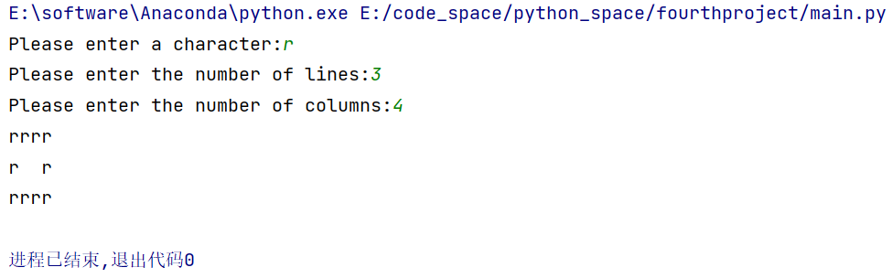

Exercise 3

